**Q1) Prompt for amount, interest rate and no. of years and calculate simple interest.**

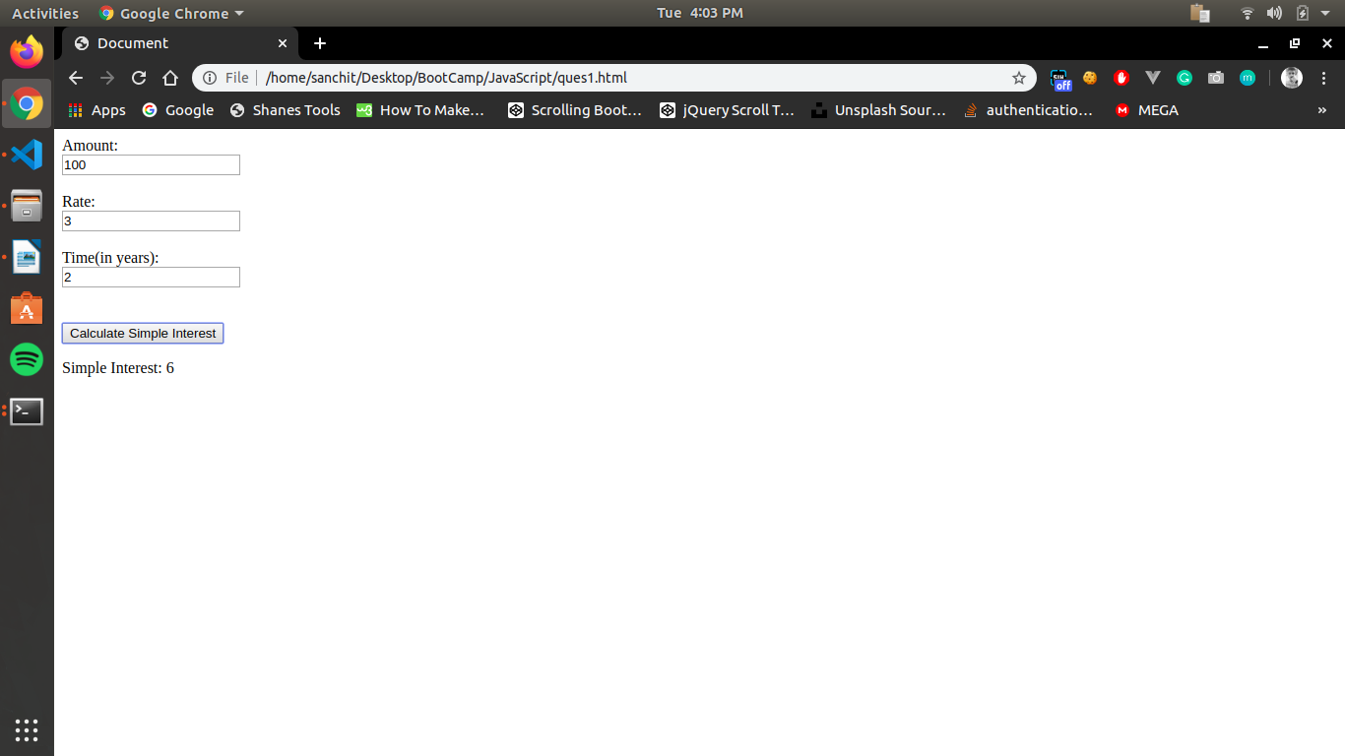

**Q2) is palindrome string**

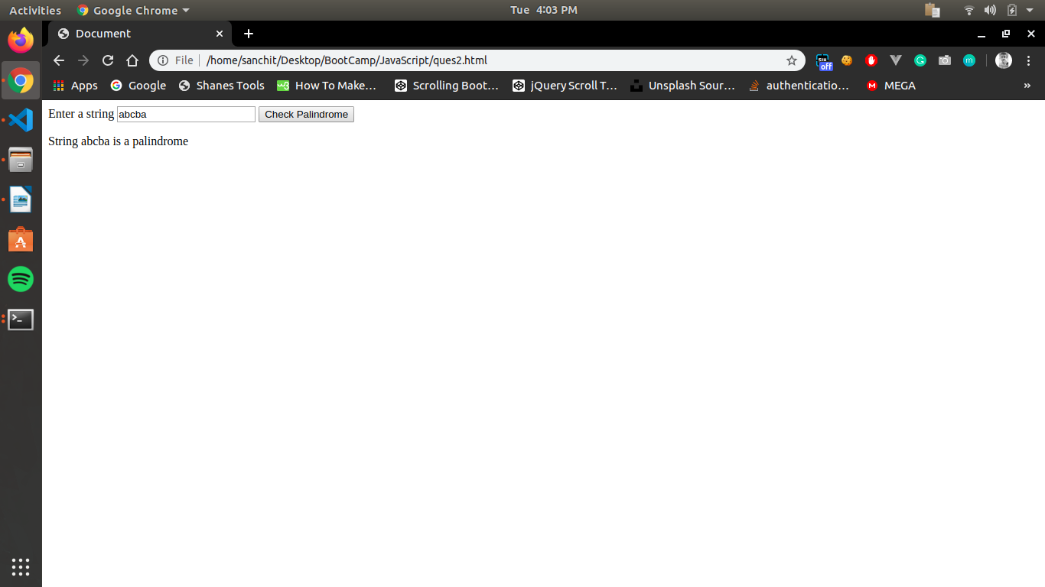

**Q3) Area of circle**

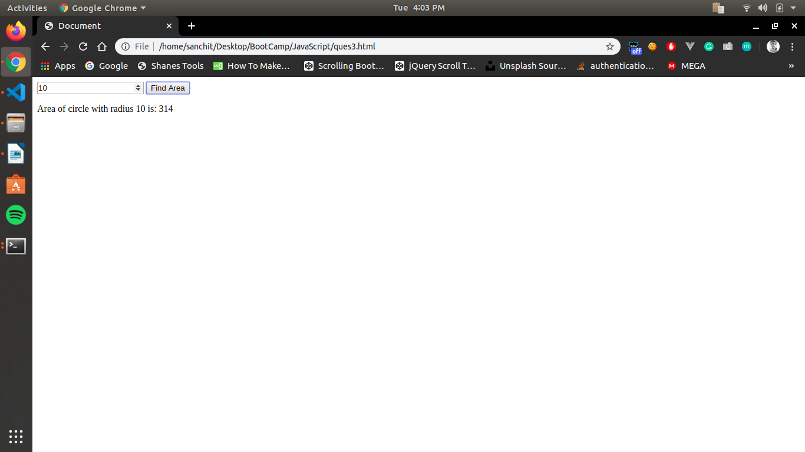

**Q4) Copy information of one object to another and log it to console.**

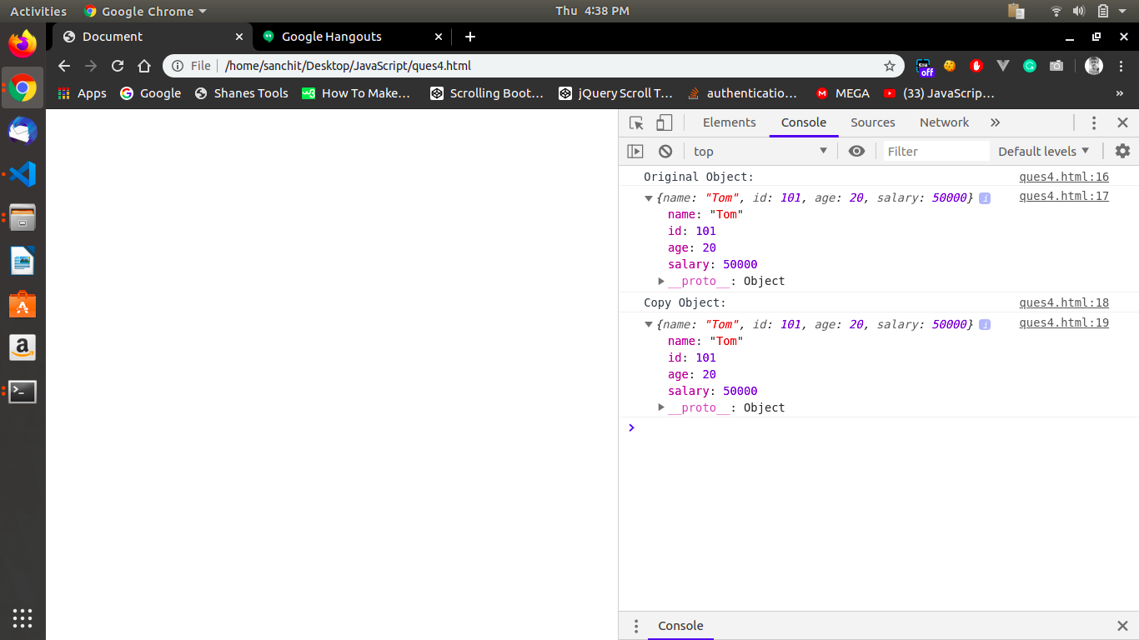

**Q5)create a list of objects of Employee with info as follow :**

* **Name, age, salary ,DOB**
* **filter all employees with salary greater than 5000**
* **group employee on the basis of their age**
* **fetch employees with salary less than 1000 and age greater than 20. Then give them an increment 5 times their salary.**

1. **Name, age, salary ,DOB**

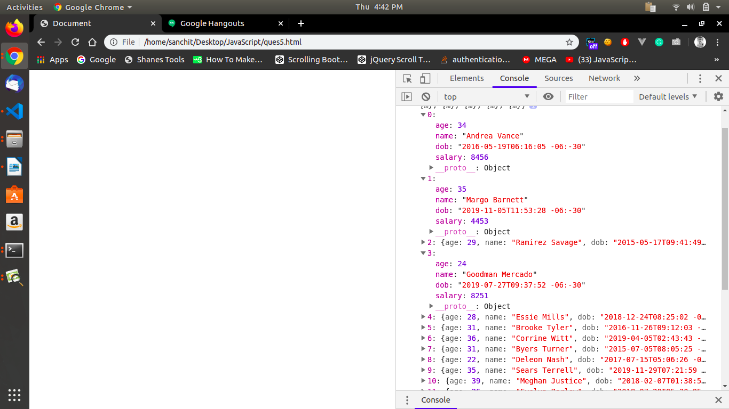

1. **filter all employees with salary greater than 5000**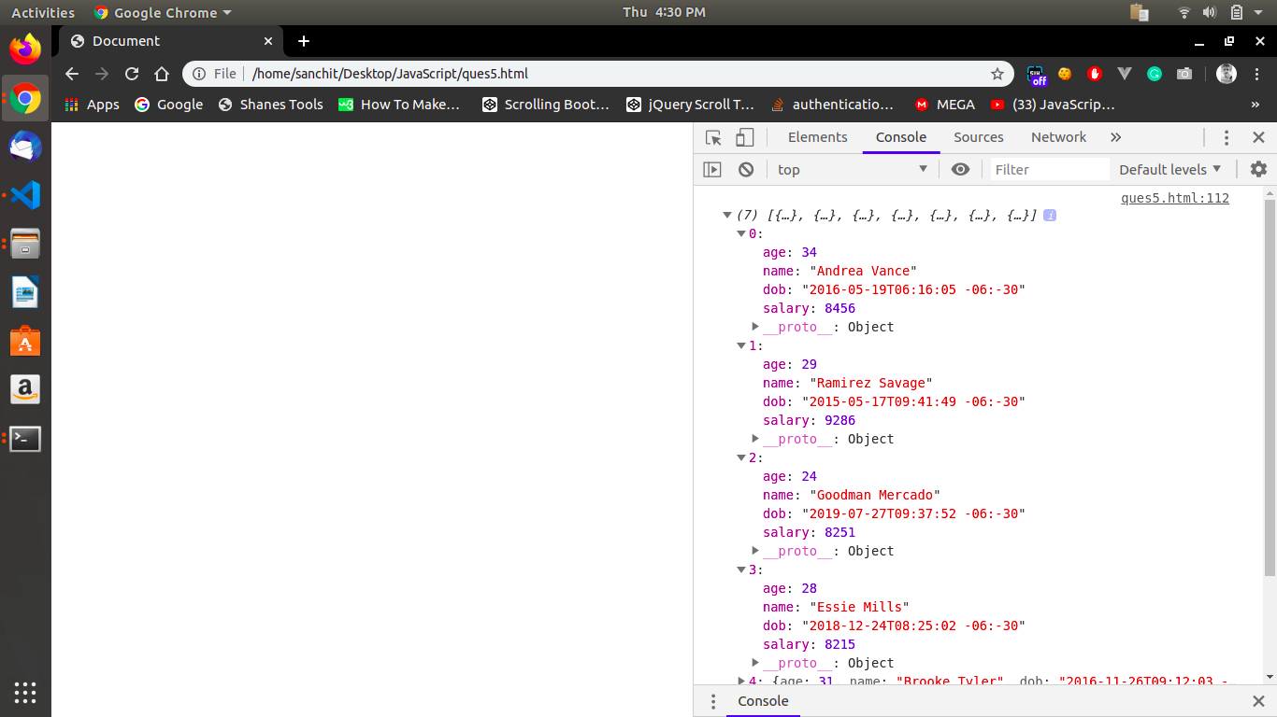
2. **group employee on the basis of their age**

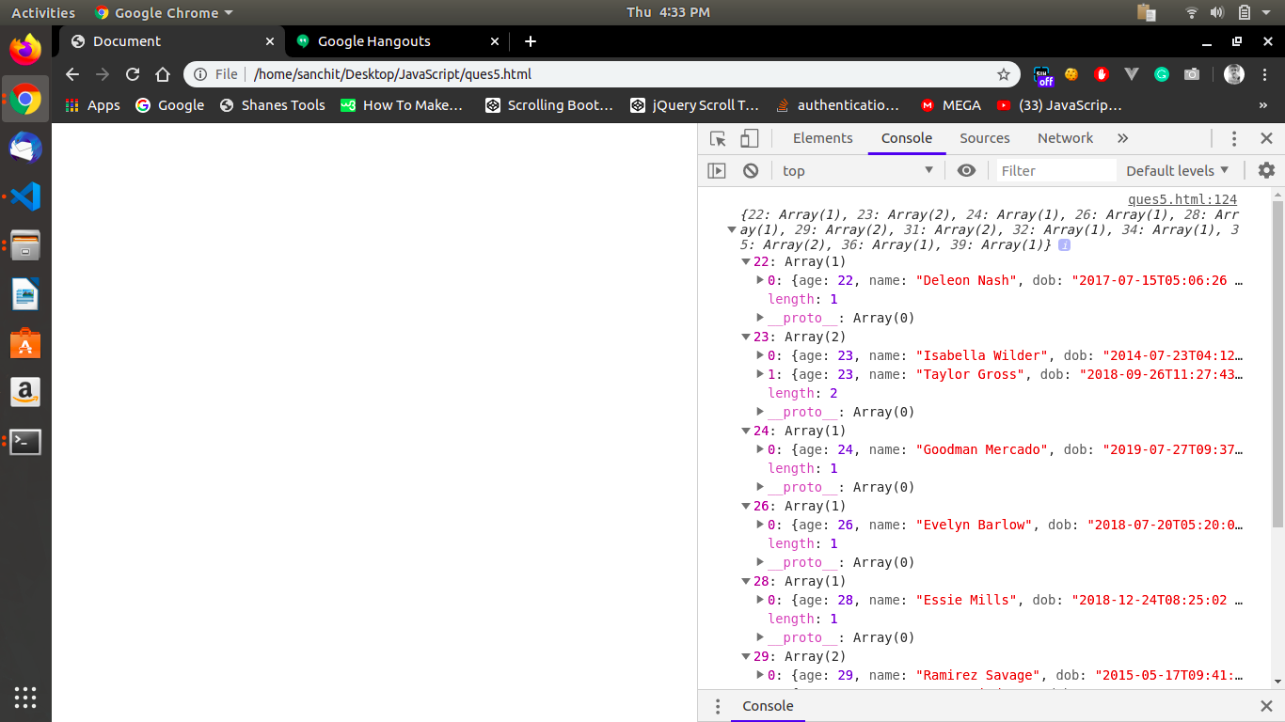

1. **fetch employees with salary less than 1000 and age greater than 20. Then give them an increment 5 times their salary.**

